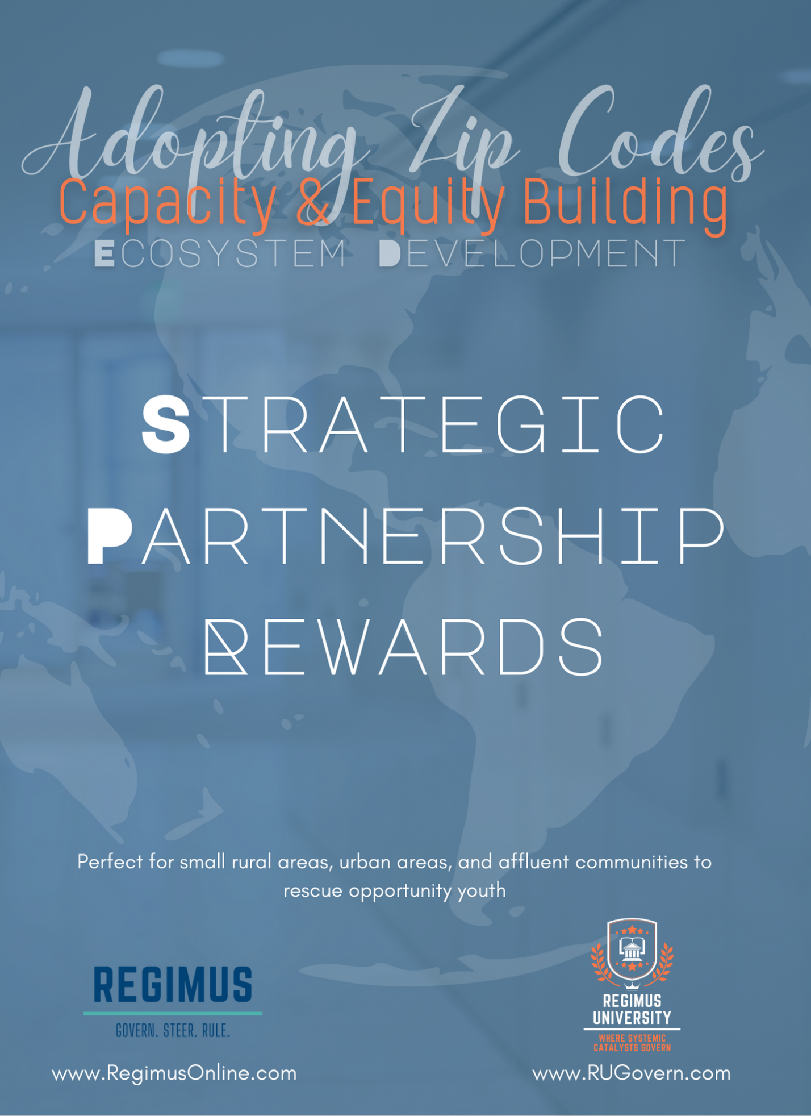

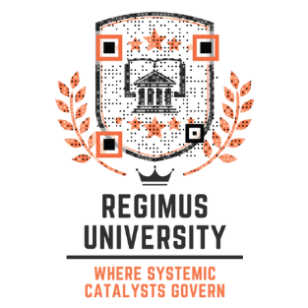
Looking for a mind-blowing benefit? Look no further! Adopt a Zip Code offers an array of practical resources that will leave you and your community jumping for joy.
Here's why you should get excited:
Unlimited Resources: As a member, you'll gain access to a treasure trove of books and resources to supercharge your community development outreach. 😊 Say hello to a wealth of knowledge at your fingertips!
Strategic Relationship Building: We're all about fostering connections and empowering leaders. Our program provides top-notch training for organizations and helps you build strategic relationships that will take your community initiatives to new heights.
Regimus I Govern. Steer. Rule. Leadership Resources: Unleash the leader within you! Our resources empower you to govern, steer, and rule with confidence. From strategic and tactical governance to community advancement, we've got you covered.
Change Trajectories: We believe in empowering future generations and creating self-sustaining youth ecosystems. Our resources guide you on a journey to make a lasting impact, enabling you to empower youth and drive positive change in your community.
But wait, there's more! Prepare to be amazed by these mind-blowing resources included with Adopt a Zip Code:
501c3 Business Plan Template: Perfect for organizations serving youth, this template will set you on the path to success and make your vision a reality.
Strategic Outreach Plan Template: Craft a comprehensive plan to reach your community effectively. Say goodbye to guesswork and hello to targeted outreach.
Tactical Priorities for Outreach: Get a step-by-step guide on how to prioritize and execute your outreach efforts strategically. It's all about making the most impactful moves!
Youth Ambassador Blueprint Template: Inspire and engage young minds both in and out of school with our blueprint template. Let their potential shine bright!
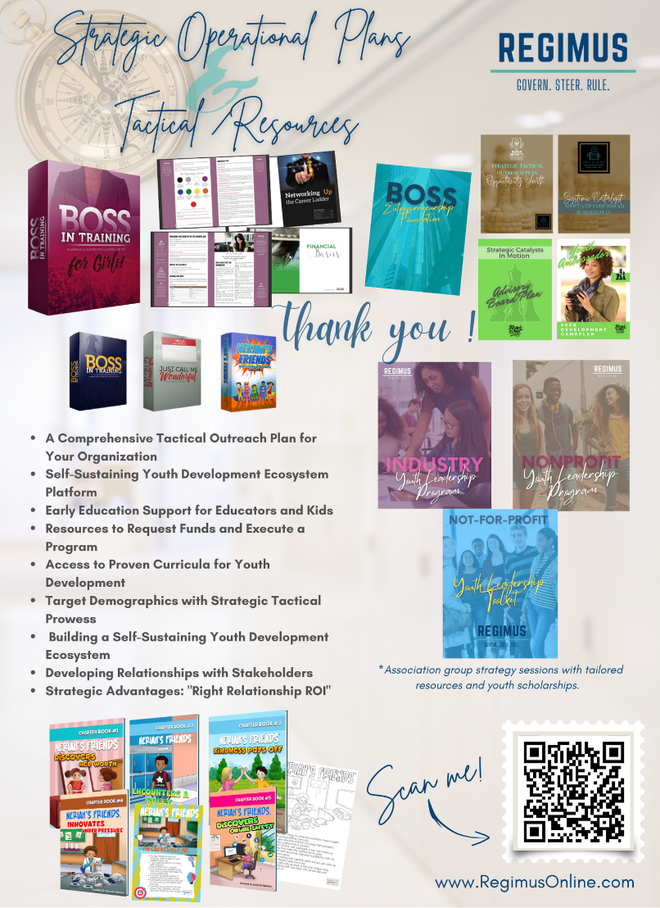
Advisory Board Template & Letters to Strategic Partners: Build a strong support network with our ready-to-use templates. Connect with strategic partners and assemble an influential advisory board that will help propel your mission forward.
Career Development Shadow Days Templates: Equip youth with invaluable experiences through shadowing opportunities. Our templates make it a breeze to organize and implement these career-building events.
College Night Plans: Smooth the path to higher education with well-structured college night plans. Prepare students for their next big step and ensure their dreams become a reality.
Proven Curricula: We've curated the best educational materials to support your initiatives. From "Just Call Me Wonderful" to "Boss In Training" and "Entrepreneurial Foundation," our curricula foster personal growth and leadership skills.
Early Education Support Systems: Lay a strong foundation for young learners with our early education resources. Dive into the captivating world of "Neriah's Friends" through our chapter books and accompanying resources.
Hidden Treasures Faith-based Design Program: Unleash your creativity and spread the message of faith through our program. Create stunning evangelism designs for adults and youth, perfect for any surface!
Journal Templates for Bookstores: Capture thoughts, ideas, and inspirations with our journal templates designed specifically for bookstores. Let the power of words flow freely!
So, are you ready to embark on this extraordinary journey? Adopt a Zip Code will equip you with the tools, knowledge, and resources to make a lasting impact in your community. Get ready to unleash your full potential and empower those around you!
Unlock the Power of Partnership: Experience the Rewards of Our Partnership Reward Program!

Join us as a strategic partner and unlock amazing opportunities! By sharing Adopt a Zip Code with others and recruiting them as partners, you not only expand our community impact but also receive a token of appreciation in the form of a financial reward.
Your efforts in recruiting other partners are invaluable in driving positive change in communities. It's a win-win situation – you help us grow, and we show our gratitude through a well-deserved financial reward. Together, let's make a difference and create a better future for all. Become a strategic partner today and reap the rewards of your dedication!

Limited Time!!! Special Code: SUM23

Consulting Package | Price before  70% Off | Sale Price | 30% Partner’s Commission
Agency Rights | $1597 | $479.10 | $143.73
Small Business Rights | $595 | $178.50 | $53.55
Individual Rights | $495 | $148.50 | $44.55

- To sign up as a partner, please use the following link: https://www.rugovern.com/affiliate_users/sign_up
- Once you’ve become a partner, your login link: https://www.rugovern.com/affiliate_users/sign_in

